姓名 | Chong Yang
教育经历 | 2017~2021，哈尔滨工业大学，机械电子工程，工学学士  2021~2024，北京矿冶研究总院，机械设计及理论，工学硕士
电子邮箱 | yangc2024@mail.sustech.edu.cn
个人照片 | 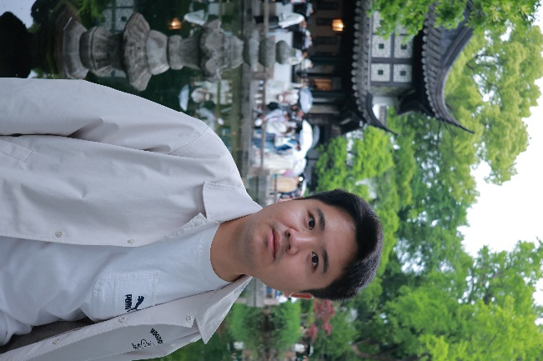
研究领域 | Soft robotics
自我介绍 | Hello, I am a PhD student focusing on soft robotics, with an emphasis on the design, fabrication, and application of novel artificial muscles. Previously involved in research on medical robots, now dedicated to exploring novel soft actuation technologies and advancing their applications in robotics and biomedical fields.
论文发表情况
*填写完成后删除括号内原文和示例图片

